Using Badges in Moodle – for students

What are Badges in Moodle?
Badges are a new feature of Moodle that are used to recognise your achievements in your course.
When you complete certain activities or demonstrate a level of skill or knowledge in a particular task, you will be awarded a badge – either by your teacher or automatically by the system.
Badges are recognised anywhere on the Internet because they contain information about your achievements and the organisation that issued the badge. In addition to being displayed in Moodle, they can be stored online in a virtual “backpack” and attached to a range of other websites including LinkedIn, Twitter, WordPress blogs, Facebook and more.
Please note that this guide has been created for eLearn, CIT’s Moodle 2.6 system and your Moodle system may look different to some of the screenshots.

How to set up an OpenBadges Backpack.
1. Go to http://backpack.openbadges.org and click “Log in or Sign Up”
2. Enter your email address to create a Mozilla Persona account. (This is free)
3. Create a password to use with Persona. (If you choose a Gmail account, you will have the option to just log in with your Google account instead)
4. You now have an OpenBadges Backpack that you can use to store your badges.
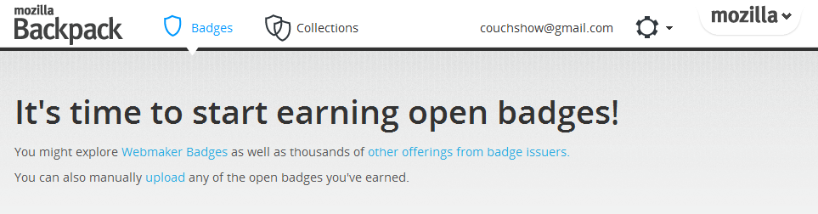

Connecting your OpenBadges Backpack to Moodle
- Log in to Moodle  - Access your profile by clicking your name  - Click Badges and then Backpack settings in the Administration section of the page.  - Click Sign in with your Email to connect your Moodle profile with your OpenBadges Backpack.  - You will need to use the login information that you used to create your OpenBadges Backpack.  - Your Backpack should now be connected to your Moodle profile. Any badges that you earn in Moodle courses can now be added to your Backpack and shared online. | 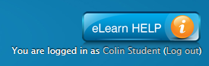  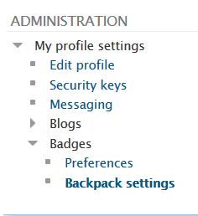  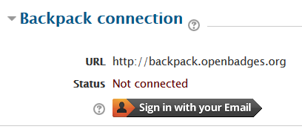  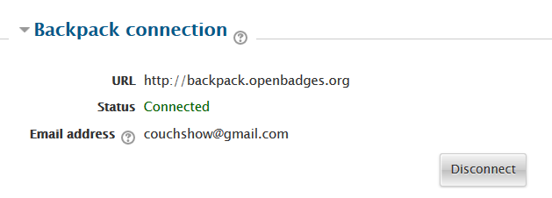

What to do with your badges
When you earn a badge, it will appear both in your profile in Moodle and also in the “My Latest Badges” section of the Moodle course that you earned the badge in.
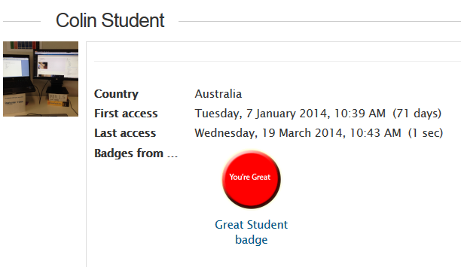 | 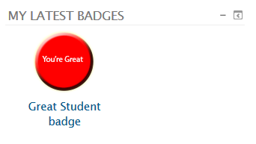
Click the badge in either of these sections to find out more about the badge and to add it to your OpenBadges Backpack.
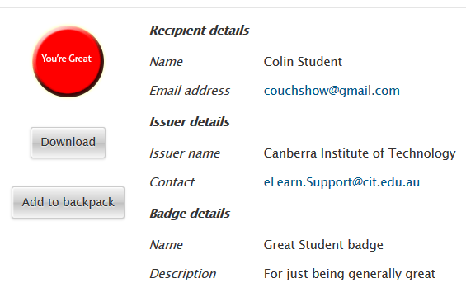
Click the “Add to backpack” button to add your badge to your Backpack. (You will need to log in)
Backpack will ask you if you want it to accept your badge – just click Yes and you’re done.
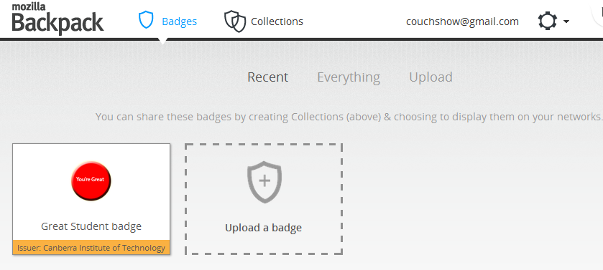
(Find out more about using OpenBadges at http://openbadges.org/about/ )

